**Experiment No.: 3**

**File transfer Protocol (FTP)**



1. **Aim**:Perform file transfer and access file using FTP.
2. **Objectives:** To make students understand the concept of and to access/transfer files using FTP Server.
3. **Outcomes:** The learner will be able to

* Analyze the functioning of FTP.
* Use the commands for building networks.
* Recognize the working of FTP in life-long learning.

1. **Hardware/Software required:** FTP Server, internet
2. **Theory:**

FTP (File Transfer Protocol) is a set of rules for transferring files between computers, usually connected through the Internet.  If your computer supports FTP and is connected to the Internet, then you can access a large number of computer systems containing a large number of files.  This facility was one of the main reasons for the initial popularity of the Internet. The program that supports the transfer of files using FTP is **ftp**.  You can access information on virtually any topic using **ftp**. In addition, you can access a multitude of archives of software for most computer systems (DOS, UNIX, Macintosh, etc.).

 FTP uses the client / server model that was discussed with **gopher**. Both client and server computers need to be running the **ftp** software.  Unfortunately most of the non-Windows versions of **ftp** are not particularly easy to use.  Ftp sites can also be connected to using Netscape and Internet Explorer, but only for downloading of files.

**FTP installation steps**

**Install ProFTPD Server**

**Code:**

1. To install **vsftpd**, enter the command:

sudo apt install vsftpd

This is an example of the output in Ubuntu.

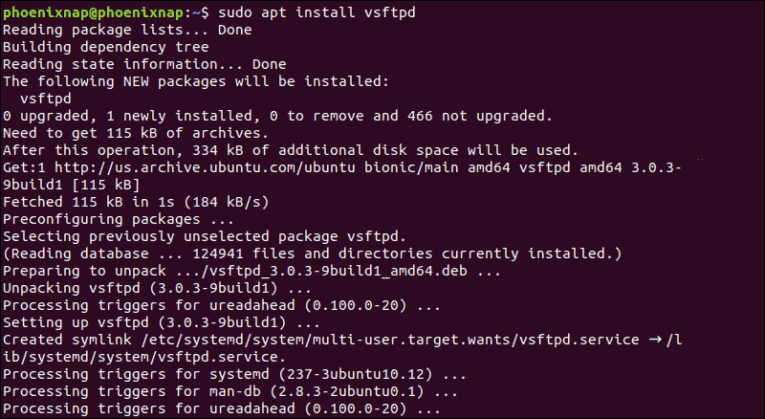

**Authenticate FTP Users**

If you want to let authenticated users upload files, edit the **vsftpd.conf** file by entering the following:

sudo nano /etc/vsftpd.conf

Find the entry labeled ***write_enable=NO***, and change the value to “**YES**.”

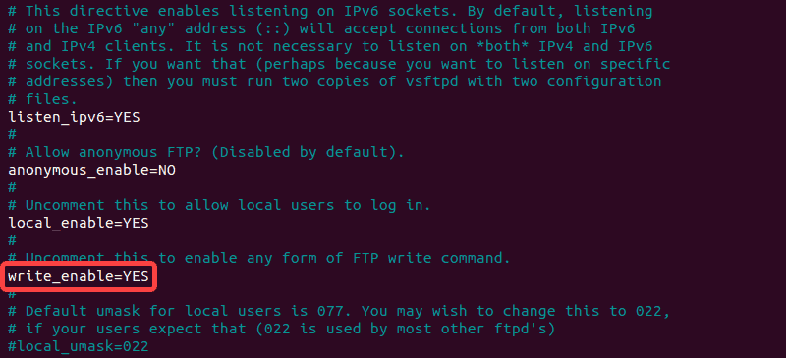

Save the file, exit, then restart the FTP service with the following:

sudo systemctl restart vsftpd.service

This allows the user to make changes inside their home directory.

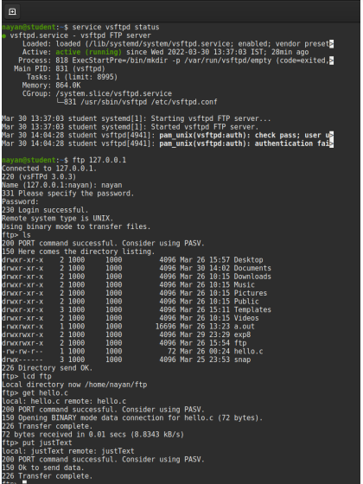

1. **Output Analysis:**

(Students should write output analysis based on the working of different topology and different networking devices used in simulation. Specify each scenario explicitly with output analysis)

1. **Additional Learning:**

(Students should write additional learning on their own based on what additionally they learnt after performing the experiment)

1. **Conclusion :**

(Students should write conclusion on their own)

1. **Viva Questions:**

* State the steps to install FTP client and server.
* FTP operates at which layer of OSI model.

1. **References:**
   1. A.S. Tanenbaum, “Computer Networks”, Pearson Education, (4e).
   2. B.A. Forouzan, “Data Communications and Networking”, TMH (5e).
   3. James F. Kurose & K W Ross: Computer Networking: A Top Down Approach, Pearson Education (LPE).